|  |  |
| --- | --- |
| Course Name | ITD 2313 – Script Programming |
| Instructor | Put instruction name here |
| Student Name | Bridgette Johnson |
| Due date | 29 January 2023 |
| Grade | Put grade earned here |
| Grading Comments | Put instructor comments here |

# Textbook Exercises for Week 3

Page 55

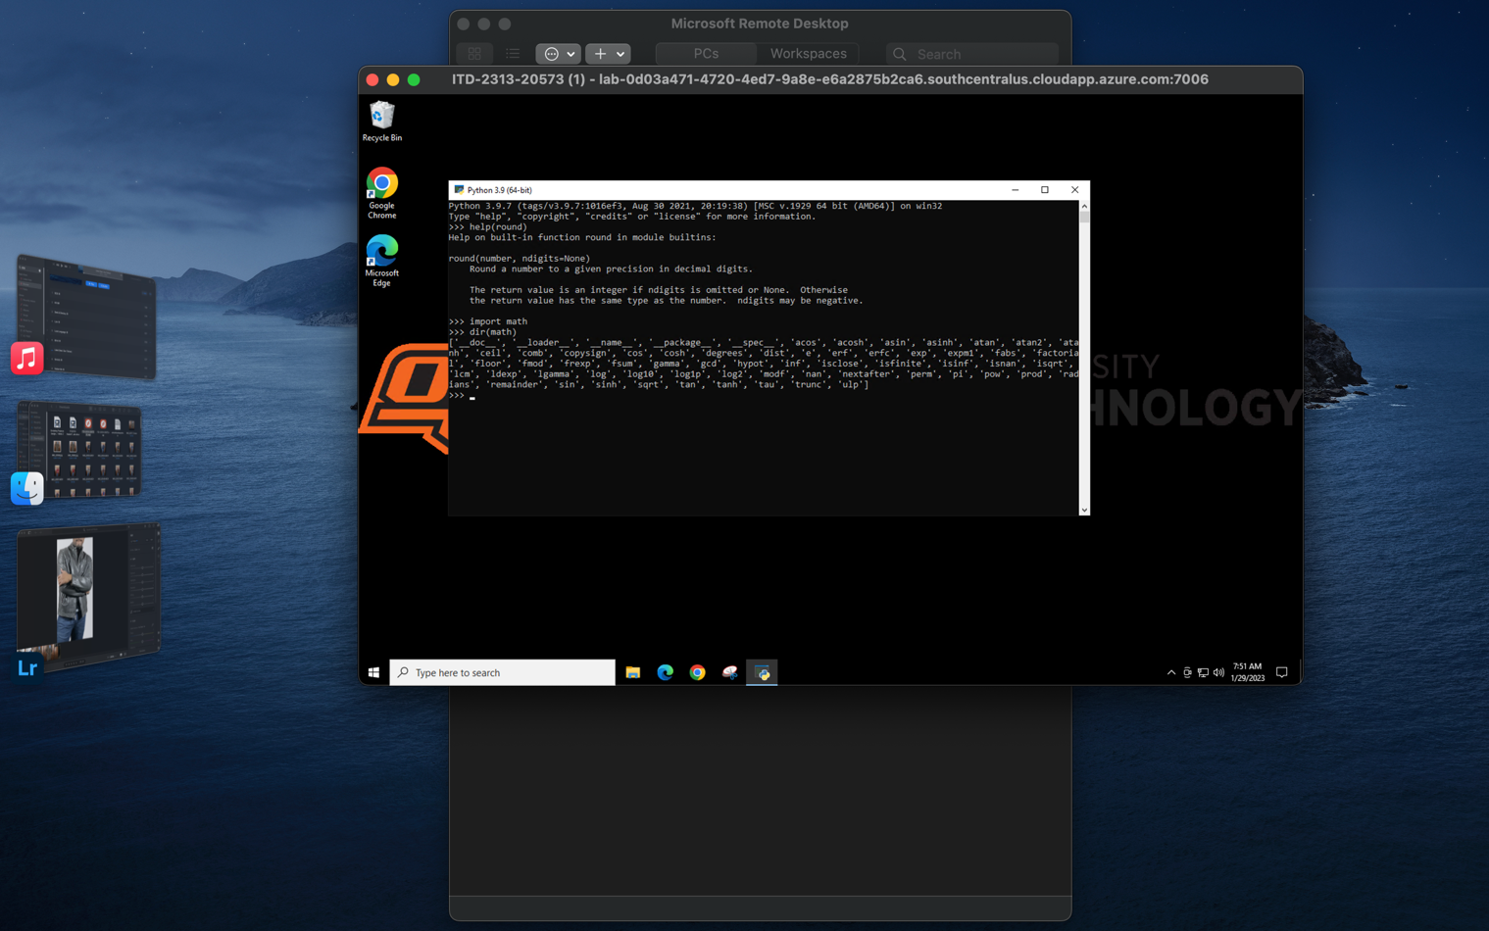

Page 56

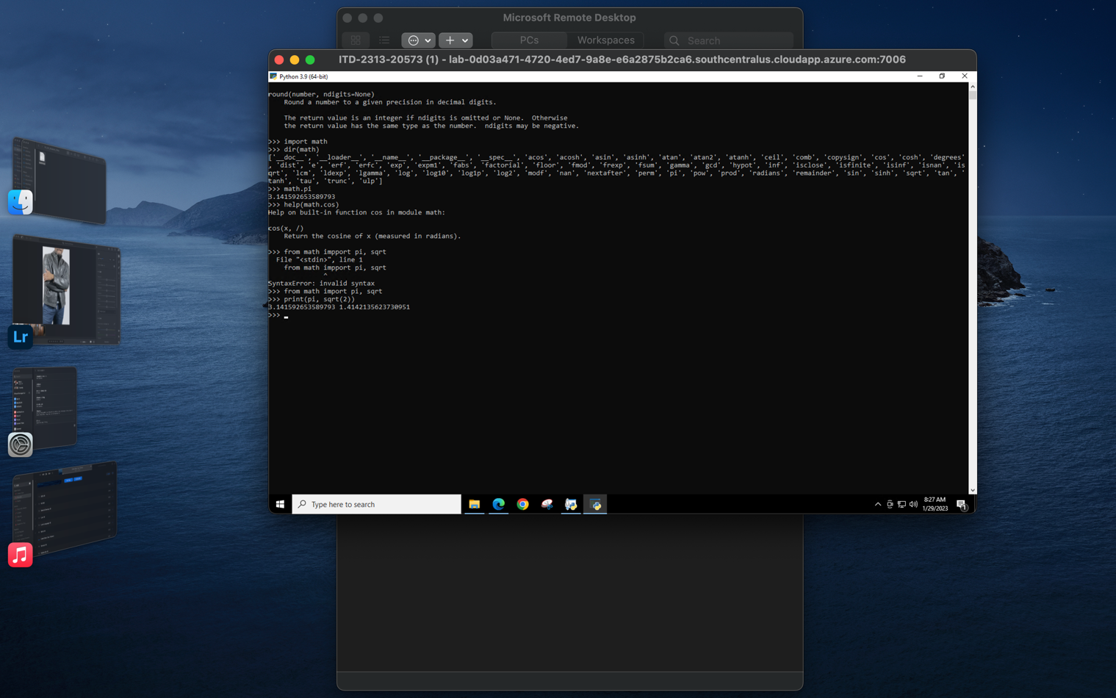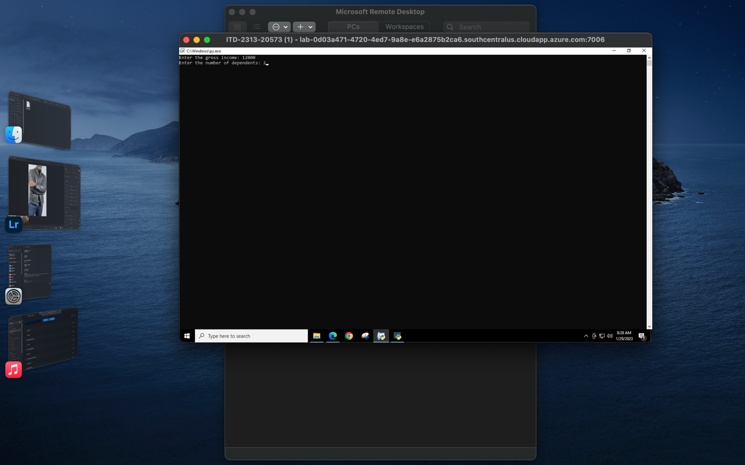

Page 57